Kevin Nunez 00323217 Linux Administration CentOs Networking Adrianna Holden Gouveia 10/10/2026
Administration of Networking Linux CentOs Server
For start this assignment I prefer to know what we have in our server, just to start from a point. To see what we have installed we are going to use the command yum history
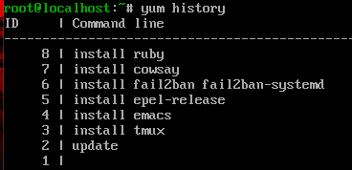
Now I want to know who is logged into our server. The w command show information about the current user on the server, and which process they are running, like their current time, how much time the server has been running, how many users are logged in the server, the system loas averages for the past 15 minutes, this command is great to check what is happening in the network.
We are going to use the w command to display online users on our server.
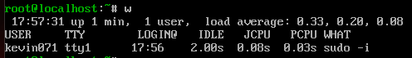
The command who let us see who is logged on the system.
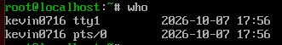
And the command who -a display more details about who is logged.
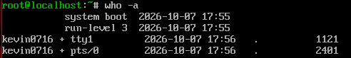
The id command this is used to display user identification information. If this doesn’t work you can run id + the user.

The command last kevin0716 can give you history for one specific username, this can give us the history of the logins, with the dates and times for be specific.
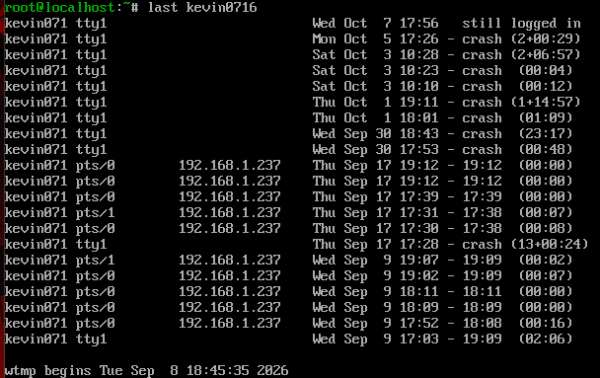

This command works for see all the users in our network, also if they are not connected in the moment, cat/etc/passwd | awk -F: ‘{print $1}’ this going to print their names. For this the awk command let print the first field of the name.
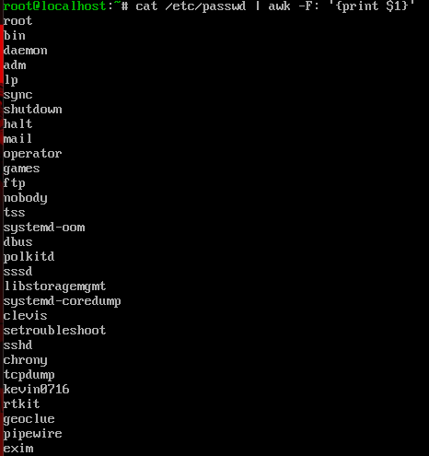
My name is almost in the bottom.

Now to finish with the user command on our server we are going to use the command without awk to see where the users are allocated and do something for groups information. Each line in the file has seven fields delimited by colon that contain the following information: Username. Encrypted password (x means that the password is stored in the /etc/shadow file), User ID number (UID). User’s group ID number (GID). Full name of the user (GECOS), User home directory, Login shell (defaults to /bin/bash). This is information we can get from cat /etc/passwd
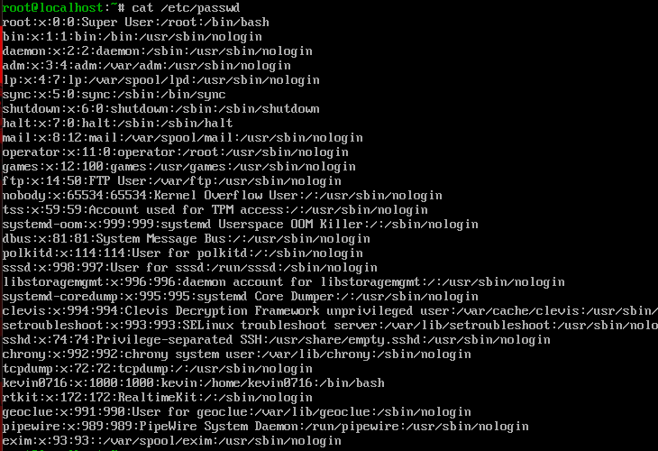

Now we are going to find about groups with /etc/group define the default system group entries from system groups that support some system-wide tasks, like print network administration, or email, the command is cat /etc/group
Group name: contain the name assigned to the group.
Group-password (x): x in this place indicates the shadow passwords are in use.
GID: contains the group’s GID number.
Username-list: List of the users that are members of the group.
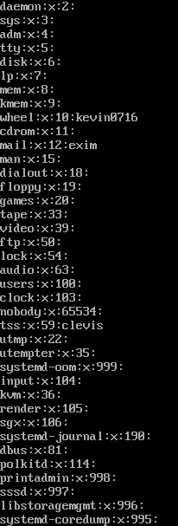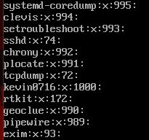

Now we are going to see some basic information about our network, like the ips, dns, ports, and other important parts.
Ifconfig(Interface configurator) is one of the most basic and common use commands for finding network details, is also used to configurate network interface parameters.
We use this to get the Ip address, MAC address, and the MTU of aviable networks.
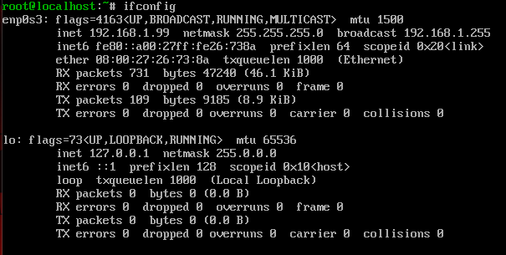
The command cat /etc/resolv.conf, this allows us to find our DNS Ip address.
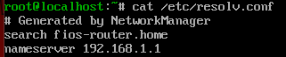

Netstat -a this command is used to display the information about the tcp and the udp, if you want less information, you can use netstat -a | less .
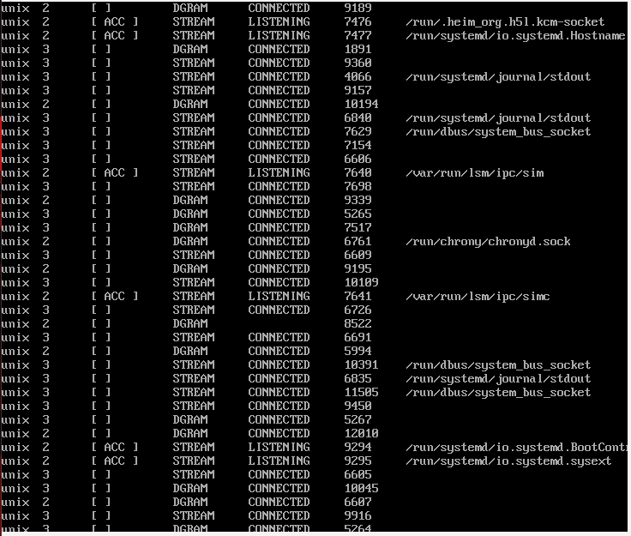

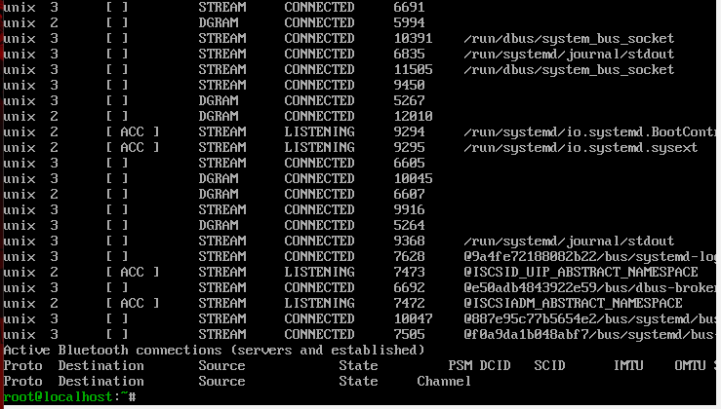

Netstat -s get all details about our ports.
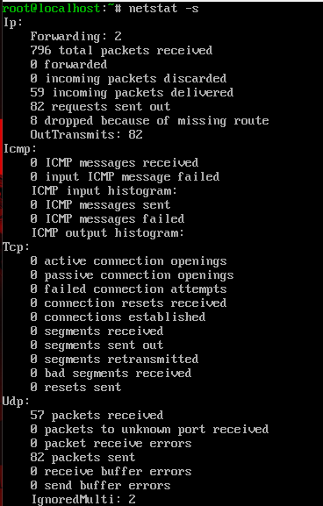
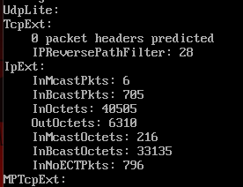
Now we are going to install a command to help us get information about webpages and more, the command is sudo yum install whois.
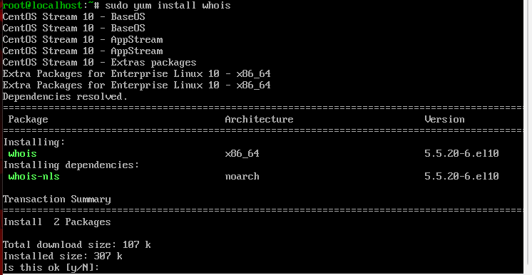
Now we put “y” for install.
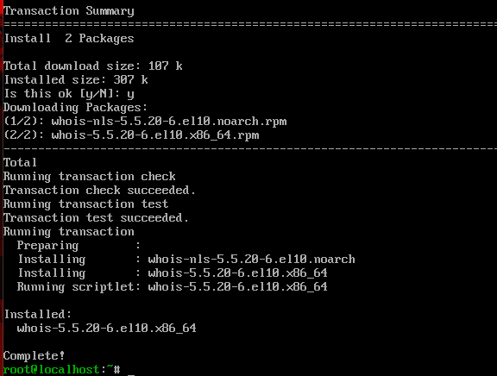
For use this command we going to test using the whois amazon.com and see what the display show about this webpage.
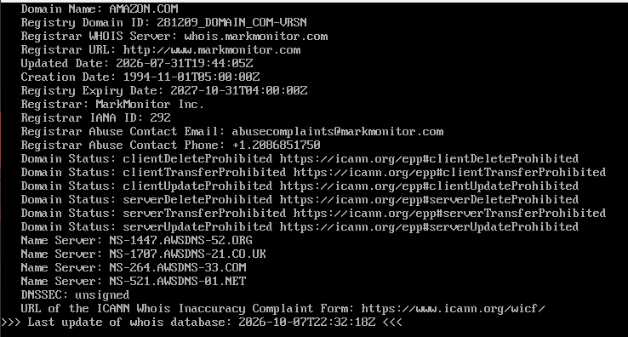
Now we going to do something with the firewall, for this we use the firewall-cmd –list-all, this check for all open ports and services.
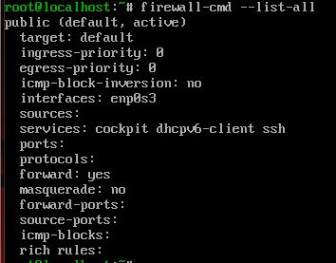

Systemctl status firewalld, this allows us to check the status and the active firewall that are working right now.
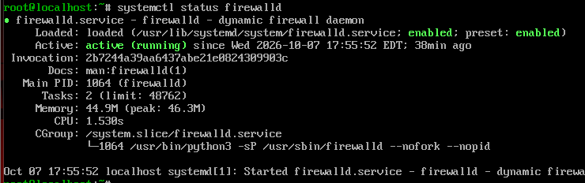
User creation, explain the script
Create a user is easy and simple, for this we need to be root, in my case is use sudo -I and became a root, now we can type sudo useradd UserName. And now we create the password for this we type sudo passwd UserName.
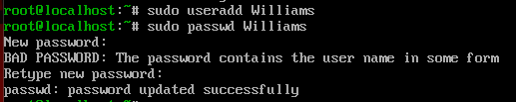
If we want to edit or something inside this new user, we type su username, and then we are inside the user. We are going to use this user for show in the script later.
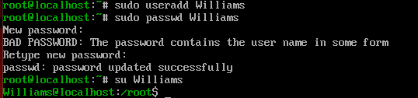

Users.sh Script
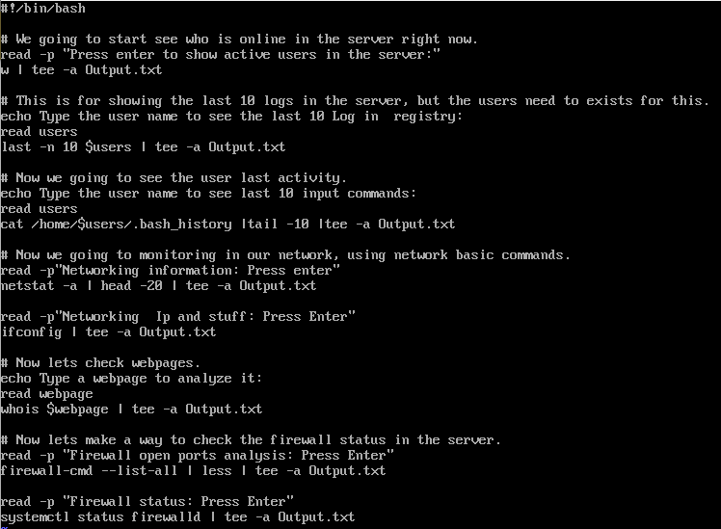
Read -p: this command read the user input before going into the next line.
tee -a: This command will display the output in the terminal and then append the output into a file.
Head and Tail -number: I used this as a combination to limit the output of information from large commands and display the information I wanted from a command. Head beginning. Tail at the end.
echo : the echo command outputs the strings of the written argument.
read $variable$: The read command will read the user input and stored as a variable.

How to run the script
For this step we need to be in root mode, because we want the admin permissions here, for this we run the command is su -I, but in your Linux, you can use su root.
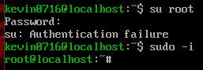
The script needs permission to be executable for this we run the command, chmod +x FileName
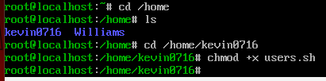
For run the script we use the command. /FileName. In my script for run it is ./users.sh
In the start on the script we need to press enter to see the active users are connected right now.
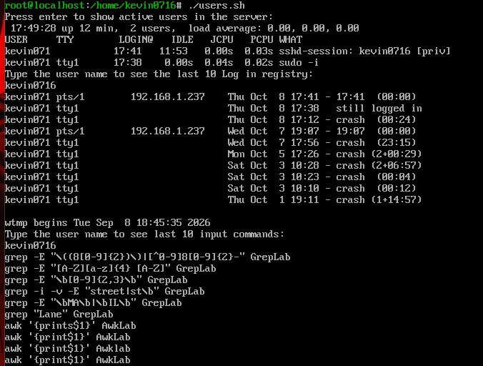
After asking you about typing a user for showing the last 10 logins.
After that the script is going to ask you about typing the user to see the last 10 commands performed in the system.
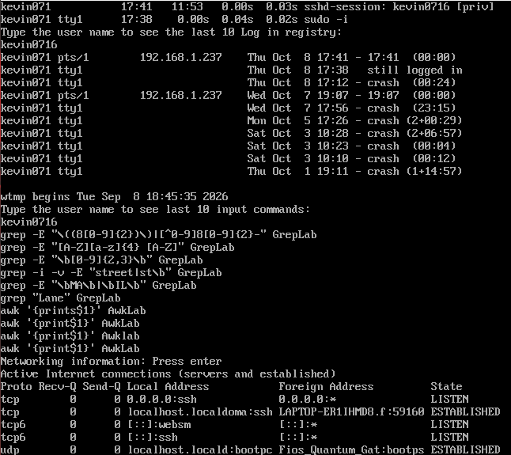

Later this asks you about press enter to show network information and know how our networking is.
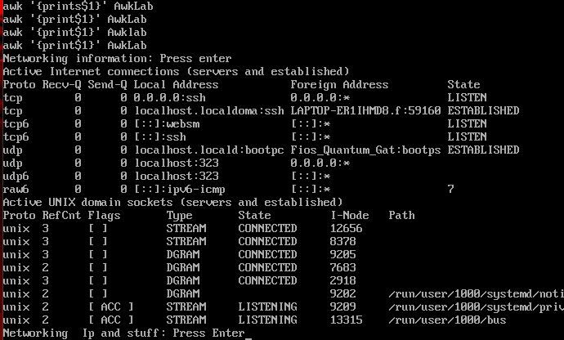

We pressed the enter again to get the IP of server in the system.
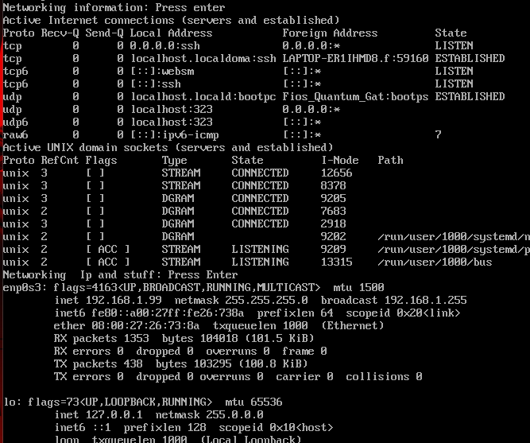

Now we are going to ask you about typing a domain for checking the webpage, for this is the whois, in my example I use amazon.com but you can try the college page, or other pages.
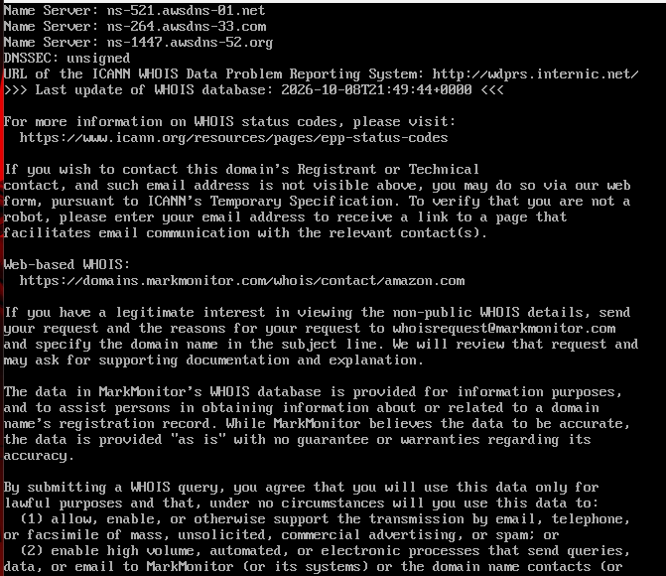

We press enter to display here information about the firewall and ports.
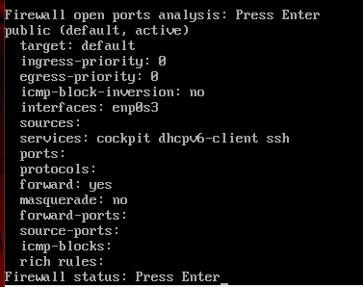
Now we press enter again to see if the firewall is active.
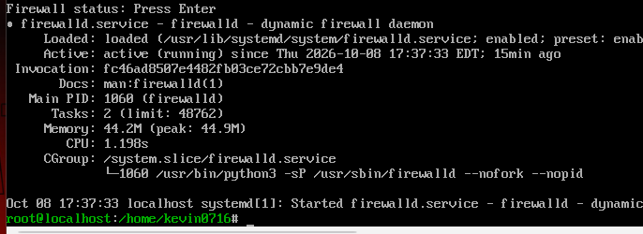
This is all for users.sh script.

Why did I decide to create my script like this?
With this I hope I can cover the fundamentals of the materials we have on the webpage. With this script we can check status, connectivity, and check if everything is secure. Check what our users are doing on the server, check the command each user uses, check the information about the network, and most importantly, check the firewall. The whois can help more by checking the domain webpages, before using it.
Sources that I use
https://www.configserverfirewall.com/ufw-ubuntu-firewall/ubuntu-check-firewall-status-ufw/
https://www.configserverfirewall.com/ufw-ubuntu-firewall/ubuntu-check-firewall-status-ufw/
https://linuxconfig.org/redhat-8-stop-start-firewall
https://www.networkworld.com/article/3228127/getting-linux-to-ignore-pings.html
https://www.fosslinux.com/42935/linux-networking-commands.htm
https://www.educba.com/networking-commands/
https://www.networkworld.com/article/3233306/more-ways-to-examine-network-connections-on-linux.html
https://www.javatpoint.com/linux-networking-commands
https://www.redhat.com/sysadmin/7-great-network-commands
https://linux.die.net/man/8/ping

Troubleshooting script
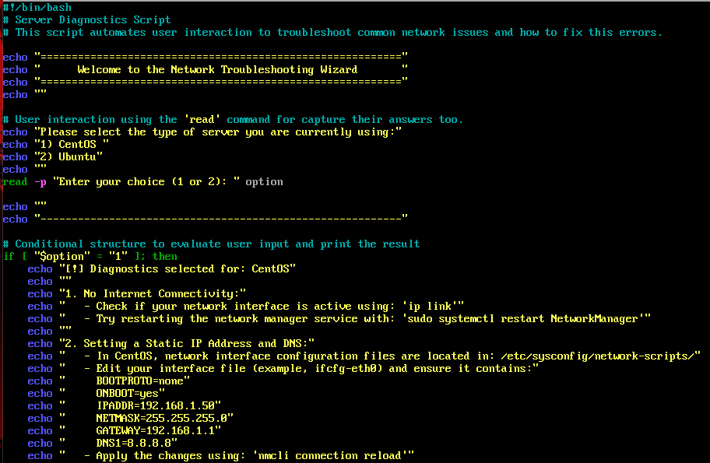
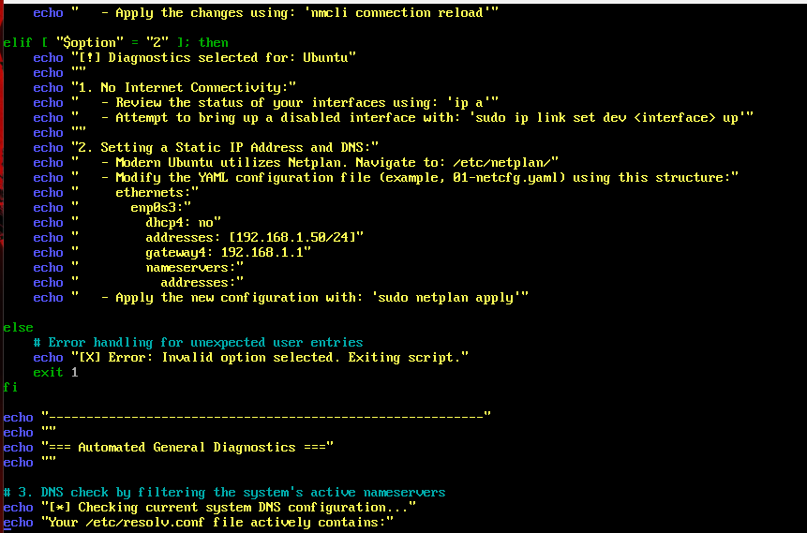
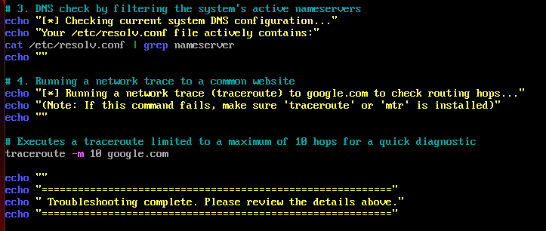

Read -p: this command read the user input before going into the next line.
tee -a: This command will display the output in the terminal and then append the output into a file.
Head and Tail -number: I used this as a combination to limit the output of information from large commands and display the information I wanted from a command. Head beginning. Tail at the end.
echo: the echo command outputs the strings of the written argument.
read $variable$: The read command will read the user input and stored as a variable.
If: the statement starts the decision-making process. It checks whether a specific condition is true or false
Then: the statement connects the condition to the action. It tells the script exactly what to do only if the condition in the if (or elif) statement turns out to be true.
Elif: the statement is used to check a new alternative condition if the previous if condition was false. You can chain multiple elif statements together to test multiple options.

First, we give permission to this script, the command is chmod +x filename, but I use in this case chmod 777 FileName
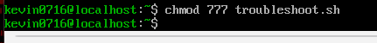

In the start we give the option, using the “if” for take 1 or 2 and decide which one you are using.
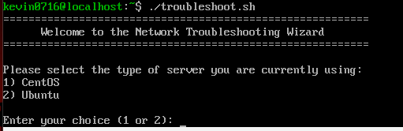
Here I choose 1 and the display shows us how to solve some of the troubleshooting we can have, and the commands that we can use if some of these are our problems in the system.
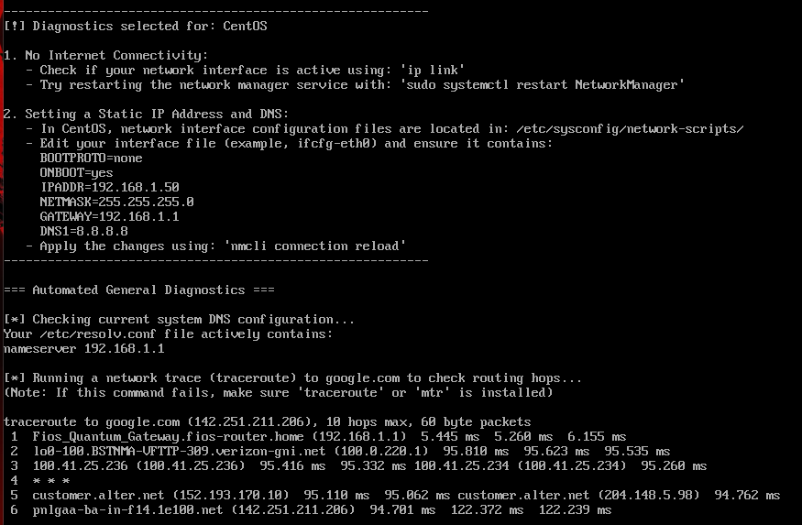
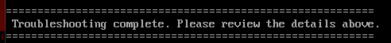

Why do I use this script?
This script is more for helping solve some problems of troubleshooting. We need to write a lot because is explaining problems and the solutions with the commands, I try to give a small manual for solving that, specific for networking.

Sources I use
https://www.geeksforgeeks.org/linux-unix/shell-script-examples/
https://www.aholdengouveia.name/introlinux.html
https://www.aholdengouveia.name/IntroLinux/shellcond.html
https://www.aholdengouveia.name/IntroLinux/shellscripting.html
https://www.aholdengouveia.name/IntroLinux/grepandfriends.html

Gitub Link
https://glorious-guide-g4956jv6gpv9cw5j4.github.dev/

